Introduction

The main goal of my study is to see how people’s perception of mental illness changes with their experience of mental illness. I am interested in working in the field of mental health, and I feel like people nowadays are still unfriendly to people with mental illness. I wrote a research paper on this topic in my freshman year, and one of my sources mentioned that contact – either people having a mental disorder themselves or knowing someone with a mental disorder – is the most effective way of reducing stigma. Therefore, I want to see if the conclusion they reached is true. My two hypotheses are as follows: people who had a mental illness before will be friendlier (give a higher score) than people who did not, and people who know someone with a mental illness before will be also be friendlier than people who do not.

Data Collection Summary:

I read through some research on related topics and designed my survey like the way they do it. I printed out little surveys and knocked on people’s door in the place I live. If the resident was there, I briefly explained the research, asked them to fill out the survey, fold it, and toss it in a box. I also let them know that the survey was anonymous. Other than that, I also brought the surveys with me and did the same thing with random people I encounter on my way. My final sample size was 263. In my survey, my first question asked if they agree to participate in this study. I removed the response of people who chose to disagree.

Descriptive Analysis of Response Variable:

(Question: How willing are you to be friends with someone with the knowledge that he/she has a mental illness?)

left skewed.

Median = 7, IQR = 3

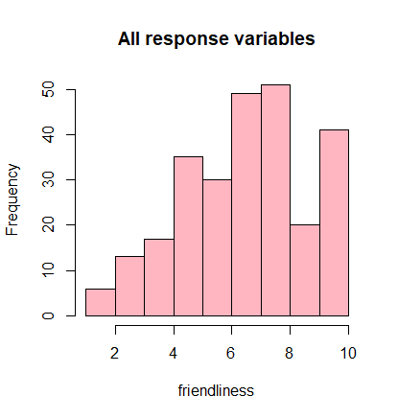

Investigation of Explanatory Variable #1: Experience

(Question: Do you personally have a mental illness or had one before?)

No Yes

217 45

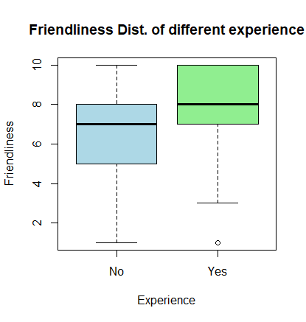People who have experience of mental illness appear to be friendlier than people who don’t, which correspond to my hypothesis.

Investigation of Explanatory Variable #2: Contact

(Question: Do you know someone who has a mental illness or had one before?)

No Yes

86 176

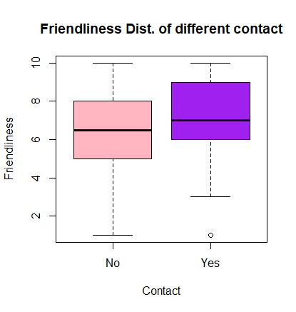

People who know someone with mental illness appear to be friendlier than people who don’t, which correspond to my hypothesis.

====================R Code====================

> mydata <- read.csv("C:/UT/Spring 2019/Biostats/Analysis.csv")

> hist(mydata$ï..Friend, main = "All response variables", xlab = "friendliness", col = "light pink")

> fivenum(mydata$ï..Friend)

[1] 1 5 7 8 10

> boxplot(mydata$ï..Friend ~ mydata$Experience, xlab = "Experience", ylab = "Friendliness", main = "Friendliness Dist. of different experience", col = c("light blue", "light green"))

> boxplot(mydata$ï..Friend ~ mydata$Contact, xlab = "Contact", ylab = "Friendliness", main = "Friendliness Dist. of different contact", col = c("light pink", "purple"))

> table(mydata$Experience)

No Yes

217 45

> table(mydata$Contact)

No Yes

86 176